# 

# Table of contents

**Table of contents** **1**

**Introduction** **2**

**Group description** **3**

Cultural background 3

**Project initiation** **4**

Group contract 4

Project description 5

**Project execution** **6**

System development with SCRUM 6

Task delegation over sprints and sprints work establishment 7

Burndown chart 7

Unified Process Diagram 8

**Personal reflections of Angel Petrov** **9**

**Personal reflections of Daniel Bergløv** **10**

**Personal reflections of Diyar Hussein** **11**

**Personal reflections of Kenneth Petersen** **12**

**Supervision** **13**

**Conclusion** **14**

**References** **15**

**Appendices** **16**

# Introduction

This project has been executed in a more organized manner than previously, due to both the use of SCRUM and the experiences with planning the project from the first semester.

Work has been split evenly between group work at campus and delegated tasks solved individually. As a group, we found it easy to work together and experienced no major issues. At times we realized, that we could have progressed faster if we had worked individually, while at other times, we could have worked faster as a group with tasks that we had delegated.

# Group description

### Cultural background

Our software development team consists of four members, two of which are Danes - Daniel and Kenneth, one Bulgarian - Angel, and one Syrian: Diyar. This group formation is new for this semester where, from a previous group, Angel and Diyar joined in with Kenneth and Daniel to form a real four man team. Looking at the cultural analysis (Hofstede Insights, 2018) of our group, we are able to clearly notice some of the data matches that of how the individuals in the group behaved and worked during the project period. For example, the individualism category index for Danes was clearly expressed during the project period, the same index being more than half less for Syria and Bulgaria. However, we see that uncertainty avoidance and long term orientation are in favour of Bulgaria, which shows that the individual from Bulgaria might have better regards in those fields.

*Figure 1 - Country comparison*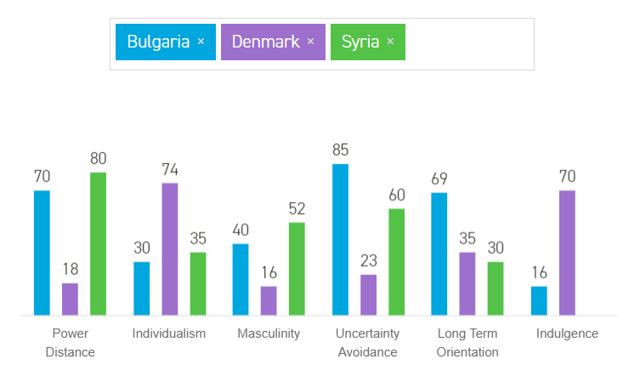

# 

# Project initiation

### Group contract

The group contract (see appendix A) was taken as it is from the first semester from the group of Angel and Diyar. It contains a rather very strict code for how to deal with work and any group related problems. There have been no alterations to it since the first semester and is to be followed to its full extent so as to avoid any uncertainties of group members, keep work at full load and ensure power of the individual if something were to happen to them or they are to take a decision related to the group.

### Project description

The internet is a great source for most information, but some types of information are more popular than other. Library systems are something that is mostly just relevant to a library, and therefore it can be difficult to find information that is useful for someone that needs to check the current market. We did succeed in the end in locating an article about a system that is broadly used in Denmark that contained relevant information about what issues libraries have found this system to have. We also located two other systems with a detailed list of features, giving us inspiration for how to structure our own project.

Our project description makes use of the issues with the first system. It also includes some features that was not mentioned in the last two systems, like cross-platform compatibility.

# Project execution

### System development with SCRUM

During the project development phase the group’s workload revolved around the usage of the agile SCRUM framework for managing workload in strict regards only to the systems’ development. Every sprint is three days long. During this period, the process of development initially started with setting the basis for system functionality and then building upon these base functionalities gradually and progressively whilst keeping important functionalities of the system as a priority and upgrading the system sprint after sprint. The following tables represent when SCRUM sessions took place:

Initial planned sprints calendar: Actual sprints calendar:

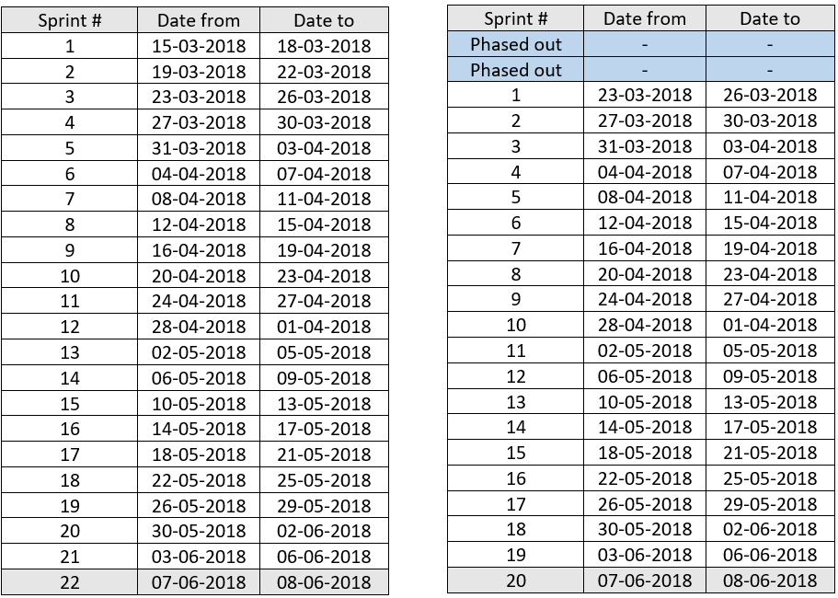

Two of the planned SCRUM meetings were phased out as a result of starting out entirely with pre-analysis - inception phase planning and system envisioning and therefore, no system development, nor documentation was done in these two sprints. The expected starting period was estimated to be from the 15th of March, 2018 but was moved to the 23rd of March, 2018, therefore leading to a lesser number of available sprints – an overall of 20 sprints in which to develop and document the development process of the system respectively. You can find the initial planned sprints calendar in the appendices section (Appendix B).

### Task delegation over sprints and sprints work establishment

Some tasks took longer than the anticipated three days per sprint, therefore, taking up more than one sprint to finish. Our development team had to deal with such tasks for a vast part of the overall twenty sprints where at some points task would take three sprints to finalize. Management and estimating workload is key in this sense and therefore a solution to this would have been to split bigger tasks into smaller ones between members, therefore distributing work more effectively. Nonetheless, all documented tasks have been completed. Backlog items – user stories have been associated with all sprint items and sprints with labels so as to remark which item belongs to which user story. At certain points, no tasks were associated with a given sprint due to focus of group

members on other studies such as completion of assignments. The following table represents which sprints had tasks and user stories associated with them and which did not:

|  |  |  |  |  |  |  |  |  |  |  |  |  |  |  |  |  |  |  |  |  |  |  |
| --- | --- | --- | --- | --- | --- | --- | --- | --- | --- | --- | --- | --- | --- | --- | --- | --- | --- | --- | --- | --- | --- | --- |
| Backlog item No. | - | 1 | 2 | 3 | - | 4 | 5 | 6 | 7 | - | - | - | 8 | - | - | - | - | - | - | - | - | - |
| Had task/s | Y | Y | Y | Y | N | Y | Y | Y | Y | N | N | N | Y | Y | Y | Y | Y | Y | Y | Y | Y | Y |
| Sprint # | 1 | 2 | 3 | 4 | 5 | 6 | 7 | 8 | 9 | 10 | 11 | 12 | 13 | 14 | 15 | 16 | 17 | 18 | 17 | 18 | 19 | 20 |

The development team has made use of the online tool Vivify Scrum, an excellent online Scrum tool, in order to keep track of tasks, sprints and the user stories associated with them. The team has concluded that there should be twelve user stories, eight of which were successfully implemented within the twenty allocated sprints. A total of eighty-two tasks have been successfully executed and completed throughout the entire project period.

### Burndown chart

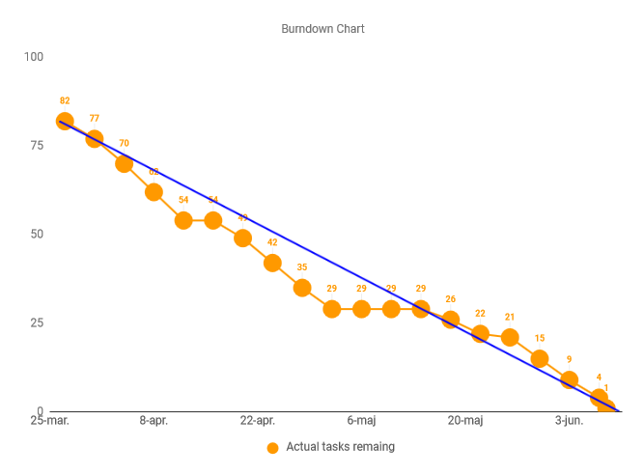

For the entire project development period, a total of twelve stories have been documented, eight of which completed, five improvements, three bugs squashed, and seventy four tasks. A total of eighty two system related tasks.   
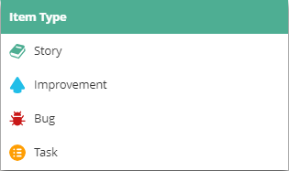

You can find a full version of the SCRUM board in the appendices section (Appendix B) and an in-depth analysis of the burndown chart (Appendix C) in the appendices section of this report.

### Unified Process Diagram

The following unified process diagram is based on the type of tasks done within sprints and intensity of the workload:

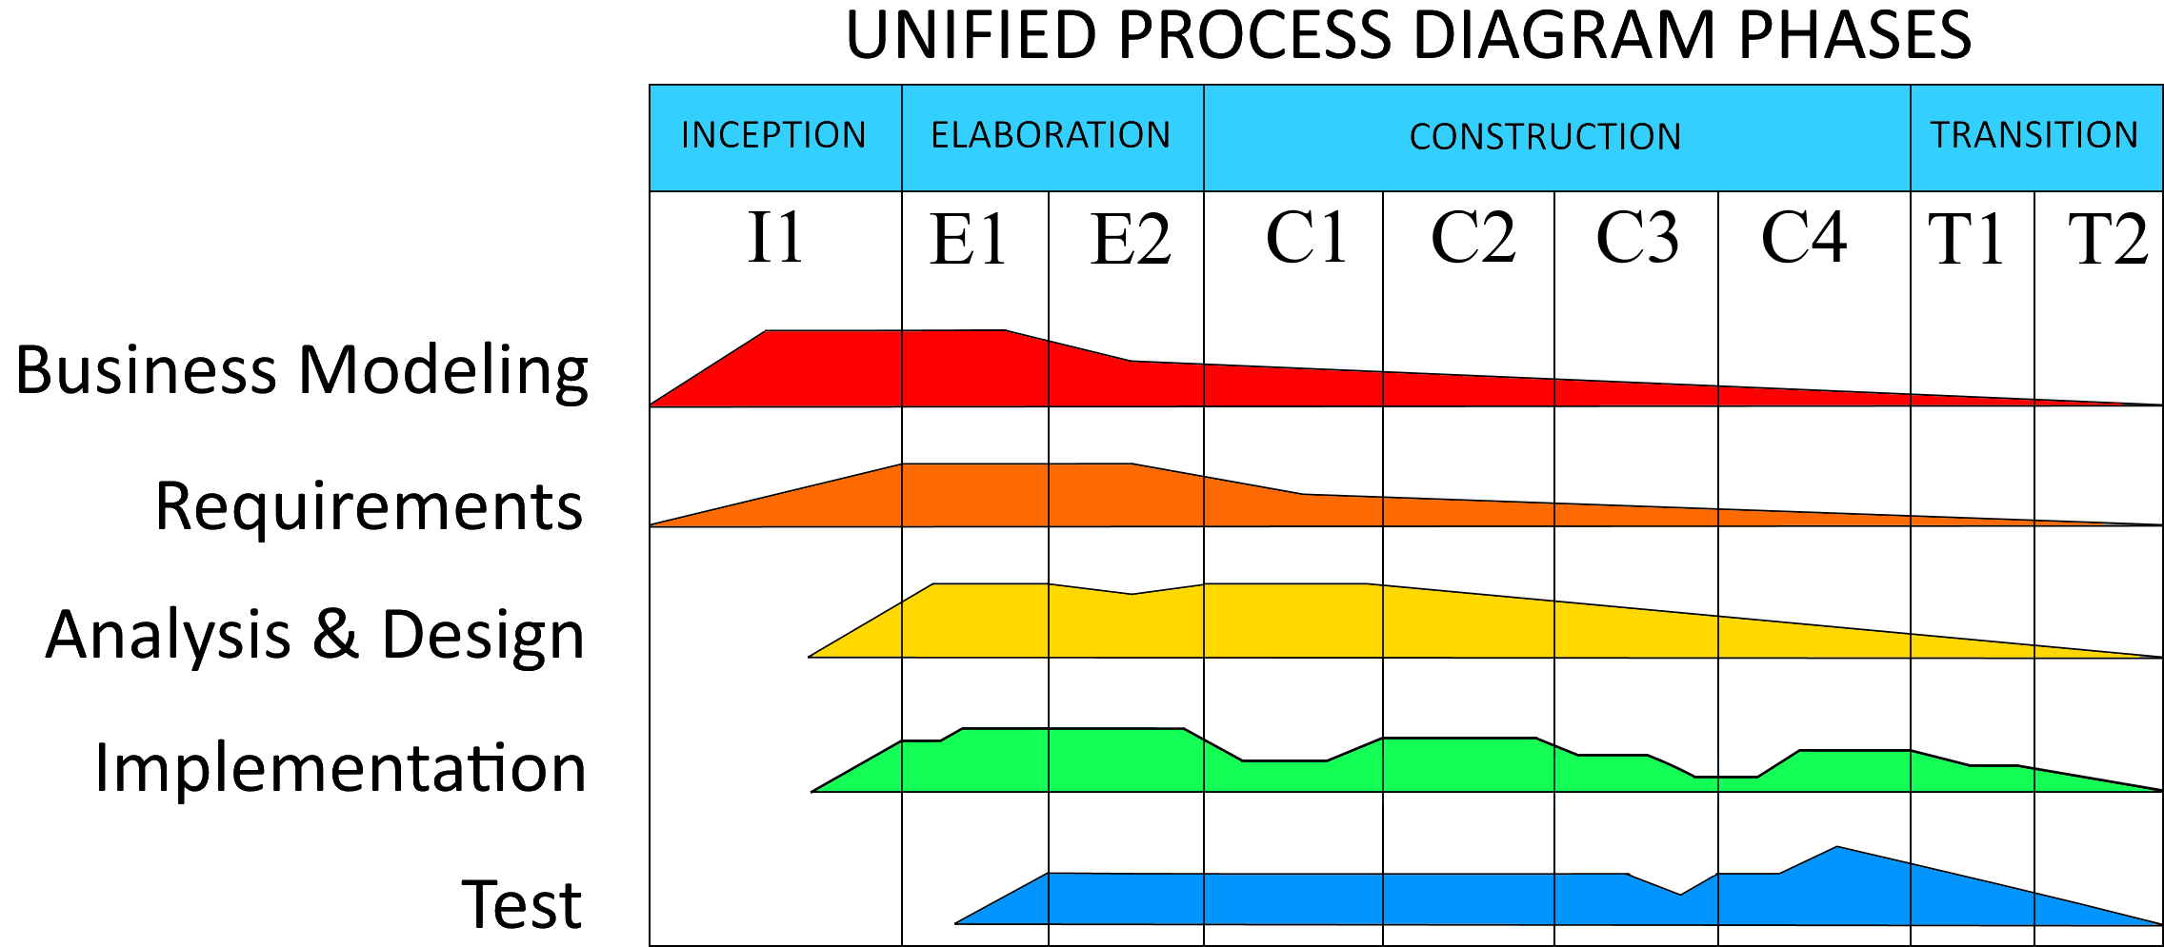

# Personal reflections of Angel Petrov

First and foremost, I am glad that there has been cooperation between all group members to achieve and deliver what is in my opinion a very good, not perfect, but very good end product of a system. Organization was spot on for all group members and thus because of this, we ended with such a result. As a scrum master, my job was to manage the work and our workflow in an efficient manner. Therefore, I put a lot of consideration in which areas every group member specialized and focused on task delegation for their field of specialization.

The system itself is nowhere near perfect, the time and a not so good envision of how the system would turn out to be, were factors that had an affect on its development. It leaves much to be desired and a lot of ideas were scraped in the bin because of not having enough time.

Therefore, I have learnt that it may be a good idea to focus on finishing even more tasks in a given time in a more efficient manner. For the group itself, we are a new formation from this second semester and we did not have almost any knowledge about each other initially which might have delayed the “hygge process” by a bit. We also had a huge gap in our programing skills and this was hard on me at first to process. Nonetheless, we have completed what is documented and handed in and me and my team will strive for even better high points in the next semester.

# Personal reflections of Daniel Bergløv

On the plus side we did manage to create a system that makes for a very nice class diagram. Sadly I cannot say the same about the actual implementation of the system. The problem with the system can be traced back to the design face in the beginning of the project. Despite the fact that we did spend a lot of time planning this system, in the end it proved not to be enough. We missed a lot of important key facts that resulted in services that did not quite do what they needed to do for proper interaction with the UI. Also the UI itself started to wander away from the initial ideas, because it was not properly documented and not specified in enough details, which was also the key factor in the problems with the services implementation. Ones these problems started to become clear, it was too late to fix them without missing the deadline.

The group was however great and we did not have any problems getting along. People met the deadlines for the delegated work in most sprints. Conflict of opinion and ideas was easily resolved during the weekly meetings.

The workflow itself was efficient and weekly tasks was planned and finished without much complications.

# Personal reflections of Diyar Hussein

In my opinion, the difference between the group members' skills was kind of disadvantage at the beginning of the semester, as some skilled mates in the group were attempting to make the system more advanced than it had to be, which made us waste some time and made me personally struggle a bit to follow the process in the beginning.

As a product owner, apart from only dealing with the product backlog and requirements, I found out that I have to do most of the analysing and designing for the project, which I found myself good at.

The positive part is that I have learned a lot during the process while working in this group. I have also found my strength points, and I developed my group working skills. Now I know how much it's easier to work in a group than working alone, the thing that I haven't fully learned from the previous semester project.

Joining a different group in this semester and not sticking to the same group members from last semester made me develop another skill in working with different developers that I haven't worked or become friends with before. This was a very good experience that would probably make me consider working in totally new and different groups every semester.

Using scrum and the unified process was great, even though we haven't followed it in the beginning, and we struggled to follow it correctly later on wasting too much time. But after understanding it, I know now how big is the difference between it and the waterfall method, and how much it gives better results and makes development funnier and more enjoyable process.

Finally, I am proud of what we have produced in this semester, even though the final product was under expectations and not totally complete, but at least we know now our mistakes, and personally, I have learned from those mistakes and will definitely avoid doing them in my next projects.

# Personal reflections of Kenneth Petersen

The group work has been relatively unproblematic. Despite of different nationalities, it was easy to organize and agree on delegation of work and the chemistry in the group was good.

In the end the system needed quite a lot of refactoring, which by then was too late. This resulted in the final system being somewhat of a patched up mess. This could likely have been avoided if the design had been executed in a different order. We agreed at too early a point to how the services interfaces should look, based on our initial idea of what the system would need. Once we really started making the GUI work, we discovered that the services were inadequate. If we had made a more in depth mockup testing of the system from a user perspective, before implementing the services, some of this inadequacy could have been avoided.

Ultimately the final product works and meets its requirements apart from a few shortcomings and despite of leaving much to be desired coding-wise, many of the ugly patches do work.

The group could also have benefitted from a more organized storage and structuring of project files, as it was often difficult to remember where we had placed a certain diagram or document when we needed it at a later time.

# Supervision

During the process, we received some help from some of the supervisors, both during the group meetings and the sessions in the relevant courses, which was critical for us to stay on the right track and do the work properly. The supervisors played especially a very important role to help us with the unified process and SCRUM.

# Conclusion

The project reached most of its goals, although we had to skip a few things that was initially planned like implementing support for extracting book information from online resources. The flow of the project work, planning and execution of sprints and so on was structured good, despite not working in some sprints because of shifted focus onto other assignments.

We did however figure out too late that our initial planning of the system was inadequate, which lead to problems down the road. We managed to patch things up in order to provide the requirements, but the implementation of these requirements, especially on a code level did not meet our initial ideas or standard. The same turned out to be the case for the structure of the UI, although it does include the features required.

# References

Hofstede Insights, 2018. COMPARE COUNTRIES. [online],

Available at: <https://www.hofstede-insights.com/product/compare-countries/>

# Appendices

**A**: Group Contract **(Group_5_Contract.pdf)**

**B**: Scrum Board **(Group_5_CLMS_SCRUM_BOARD.html)**

**C**: Burndown Chart **(Group_5_Burndown_Chart.xlsx)**

**D**: Schedule **(Group_5_SEP2_Schedule.pdf)**

**E**: Analysis **(Group_5_Pre_Analysis_System_Concepts.7z)**